PROJECT NAME: NATURALLY DELICIOUS

BY

PARTHAVI PARIMAL KHATU

EDUREKA PRESENTS

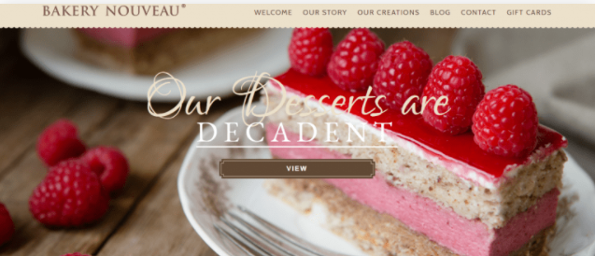

*OVERVIEW: It’s an e-commerce website for ordering cakes,pastry etc.

*NAVIGATION BAR(ON TOP)

1.HOME

2.ABOUT US

3.LOGIN AND SIGN UP PAGE

4.MENU

5.CART

6.PAYMENT PAGE

**Page Structure:**

**Login Page:** Just like a usual login page, asks user to enter login id and password

**Home page:** Link to profile page

**Profile page structure:**

Personal details

History

Items added to cart

Filters

Search bar

Shows option to see items in the cart.

**Product page:** Shows description of selected product in detail Add to cart Or Buy now.

**Buying options:** 1.credit card

2.debit card

3.net banking

4.paytm

5.etc

**Basic Features:**

**Login page:**

Login id input(*required)

Password input(*required)

Login button

**Sign up page:**

Form --> takes personal details as input

Name

Mobile number

Mail id

Address

Sign up button

**Home page:** Search bar to search cakes or by product name

Filters

Horizontally aligned

Or

Vertically aligned

(will try which looks good for my website)

Link to profile page

All the personal details entered during signing up + Option to edit them

Items in cart Shows products added to cart + option to edit them(delete any)